CAREER OBJECTIVE:
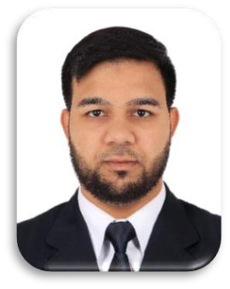
MOHAMMED ABDUL SAUD DANISH ZAIMI
Phone: +971-581772209 Dubai-United Arab Emirates

POST APPLIED FOR : DRIVER
A suitable position with an organization where I can utilize the best of my skills and abilities that fit to my education, skills and experience a place where I can encourage and permitted to be an active participant as well vital contribute on development of the company.
PERSONAL DETAILS:
- Nationality : Indian
- Date of Birth : 12-02-1997
- Religion : Muslim
- Marital Status : Single
- Gender : Male
- Language Known : English & Urdu
EDUCATIONAL QUALIFICATION:
SIRA:
Security Industry Regulatory Agency (SIRA) UAE. 2021 UNIVERSITY:
B. com 2nd year from Telangana University.(Mar-2016)
INTERMEDIATE:
10+2 with 65% from Board of Intermediate Examinations(Mar-2014).
SECONDARY:
S.S.C. with 70% from Board of Secondary Education (Mar- 2012).
WORKIGN EXPERIENCE
Worked as a Security Guard 5’YEAR with MIDDLE EAST BUILDING SECURITY L.L.C in Dubai( Fab
2018 to Till Date)
INTEREST AND HOBBIES
- Learning new Technologies.
- Talking to people and learning new things
- Highly inspired individual with strong team orientation.
- Ability to solve any problem efficiently and precisely in a given field
- Reading, Adventures, Sports, Computer Games
UAE DRIVING LICENSE DETAILS:
- License No : 4422411 ( Light Vehicle)
- Date of Issue : 26-01-2023
- Date of Expire : 26-01-2025
- Place of issue : Dubai
PASSPORT DETAILS:
- Passport No : R0601195
- Date of Expire : 02-03-2025
- Place of issue : India
DECLARATION:
I hereby certify that the above information are true and correct according to the best of my knowledge & my experience.

